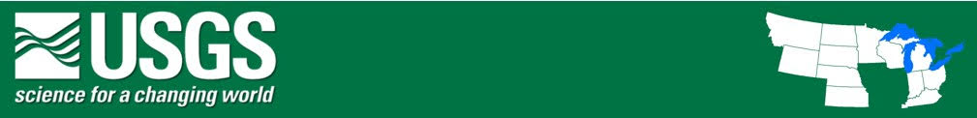

**Midcontinent Region Highlights Feb 14-Feb 18, 2022**

**Upcoming Significant Publications or Science Products (not yet published)**

4/15 Nature Reactions of lithium in the aquifer Amber Zimmerman

4-22 Science Effects of forest fires on the soil Daniel Mrva

**Upcoming Meetings, Events, or Scientific Achievements**

**Significant Collaborative Research or Science-Support Activities**

**Media Interactions**

**Past Significant Publications**

**Past Meetings, Events, or Scientific Achievements**

**Significant Collaborative Research or Science-Support Activities**

**For the Record**

**Congressional Interactions**